Docker
Ahmed Ehab Ahmed
Lab-2

Problem 1 (Bonus) :
- Run a container nginx with name my-nginx and attach a and attach a volume 2 volumes to the container
  - Volume1 for containing static html file
  - Volume2 for containing nginx configuration
- Edit the html content
- Remove the container
- Run a new 2 containers with the following:
  - Attach the 2 volumes that was attached to the previous container in two different ways (volume mount – bind mount)
  - Map port 80 to port 8080 on you host machine
  - Access the html files from your browser
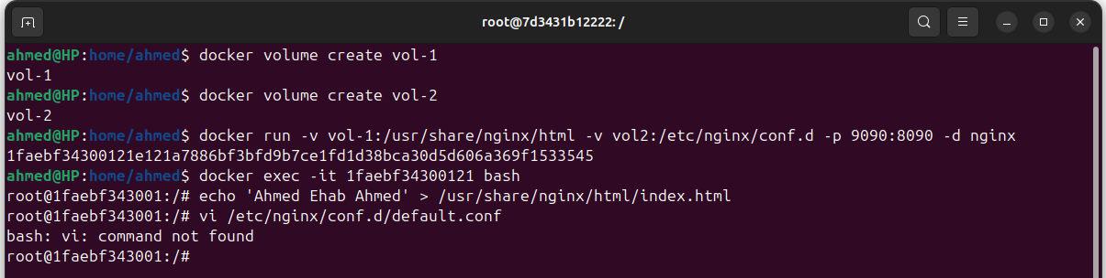
apt-get update
apt-get install vim -y
vim /etc/nginx/conf.d/default.conf
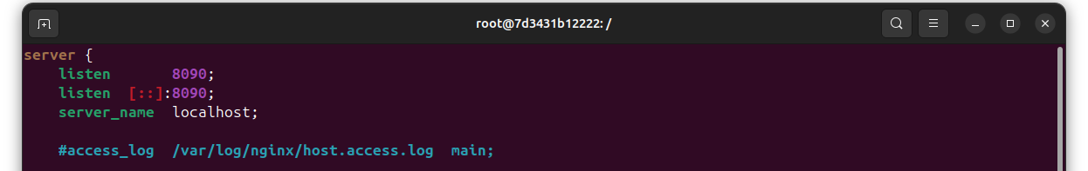
exit
docker rm -f 1faebf343001
mkdir -p ~/my-nginx-config
sudo cp -r /var/lib/docker/volumes/vol-2/_data/. ~/my-nginx-config/
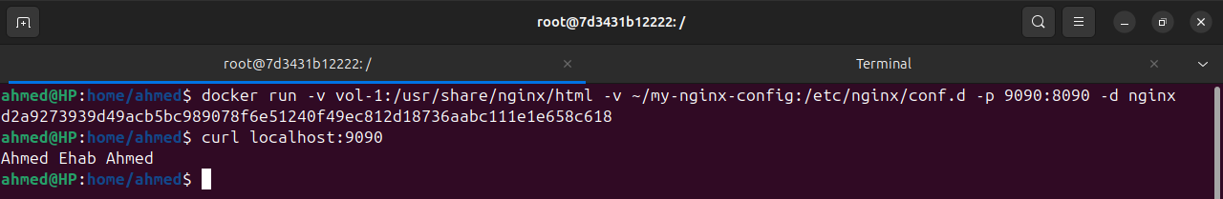
Problem 2:
- Create a dockerfile for nginx image with different html content and different nginx conf that listen to port 8080 instead of port 80 on the container
- Create container from the new \image

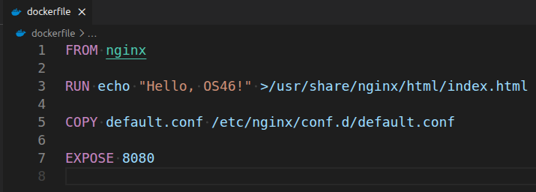
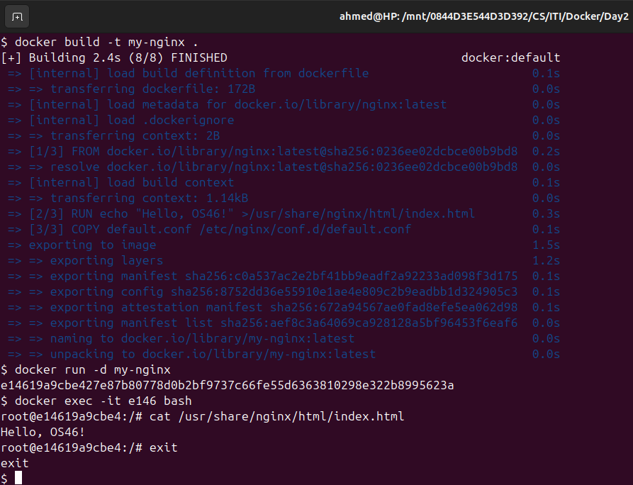

Problem 3:
- Create a reactjs simple app
- Create a dockerfile to containerize the reactapp
- Build the image and test it
- create a dockerfile for the same app in smaller size using multi staging
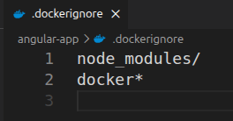
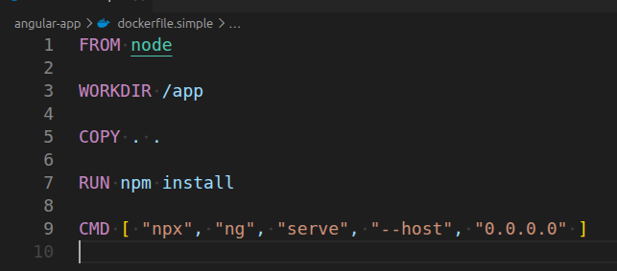
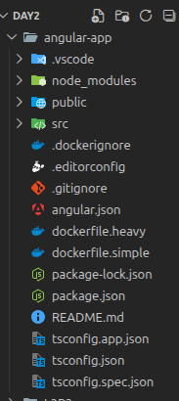
docker build -t angular-heavy -f dockerfile.heavy .
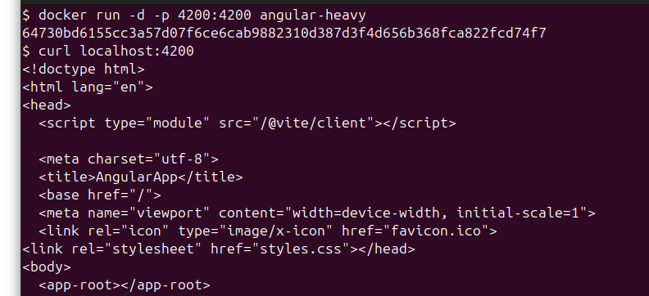
==============================================================
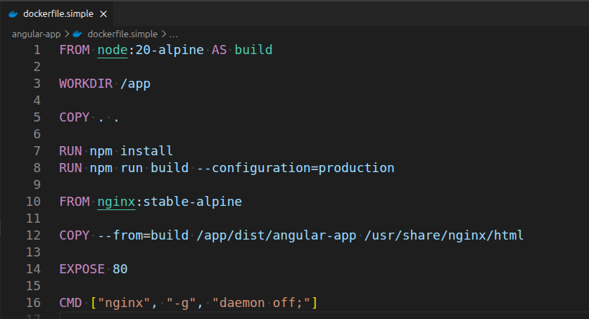
docker build -t angular-simple -f dockerfile.simple .
